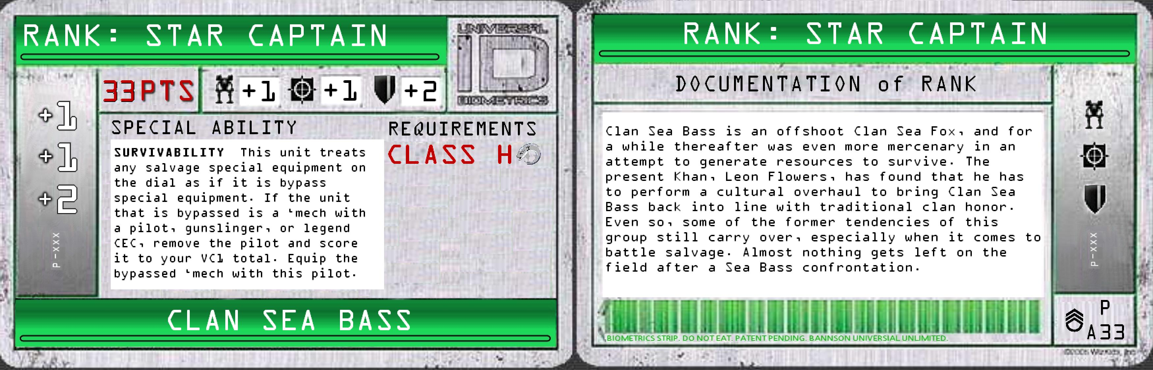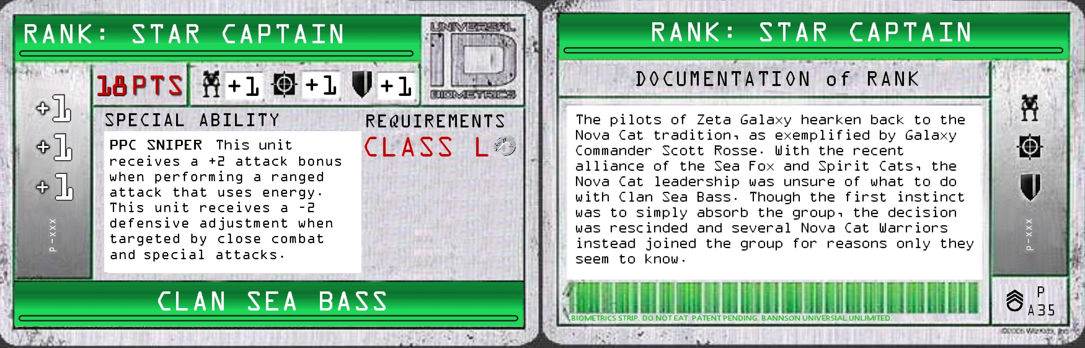\

The following card (P-A31 Comstar: Adept) is now numbered P-A39:

